Unit 1

1. Explain database and its components in detail.

2. Explain file and its types.

3. Explain operations on a file.

4. Explain  a. Entity    b.  Attribute  c. Domain d. Instance  e. Tuple

5. Explain data and its types

Unit 2

1. Write any 4 differences between DBMS and RDBMS

2 What is metadata?

3. Explain the structure of DBMS

4 What are the different types of users role in database environment.

5. Explain different services provided by DBMS over conventional file system.

6. What is RDBMS? Explain different relational db components.

7. Discuss different applications of DBMS.

Unit 3

1. What is data model? Explain basic types of data model.

2. What is set operator? Explain set operations with example.

3. What is foreign key? Explain foreign key ir referential intergrity constraint.

4. Explain record based model with example.

5. What are joins ? List down the types of joins.

6. Explain types of integrity constraints.

7. Explain hierarchical model with an example.

Unit 4

1. Whqt is relationship? Explain types of relationship.

2. Explain with example weak and strong entity.

3. Explain the concept of candidate key, super key and primary key with example.

4. What is attribute? Explain any two attributes with example.

5. What is keys? Explain any keys of relationship sets.

6. What is ER model? Explain the steps in ER model.

7. 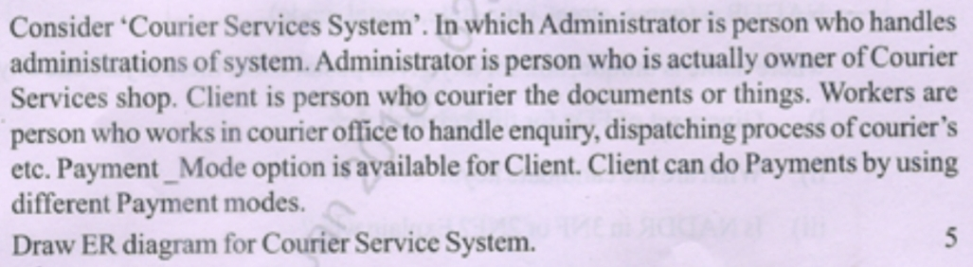

Unit 5

1.What is normalization? Why we need normalization?

2. What is functional dependency and its types? Explain with example.

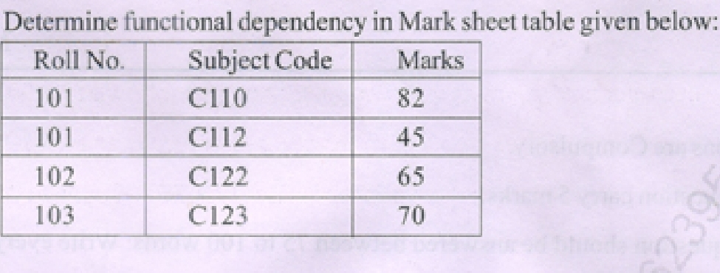

3. What is denormalization?

4. What is decomposition or small schema with an example.Explain its types.

5. 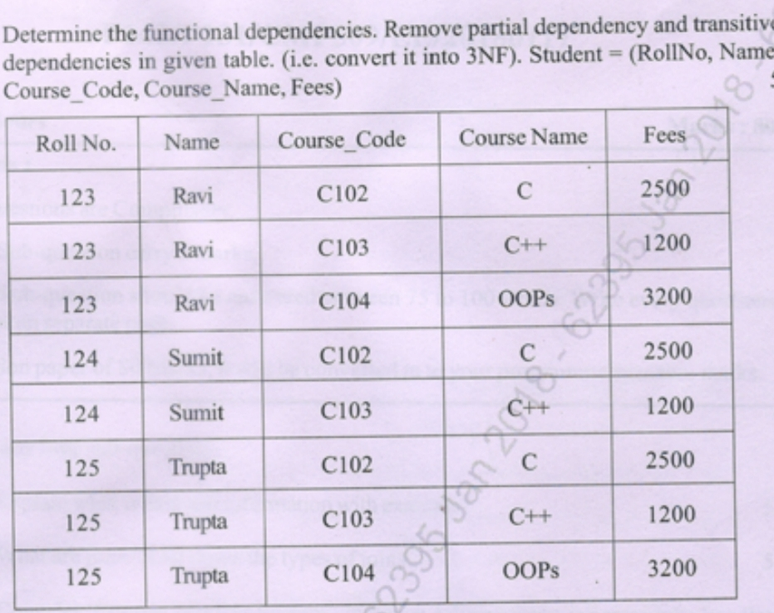

6. What are the advantages and disadvantages of normalization.

7. Explain types of normalization with example.

Unit 6

1.Explain any five datatypes in SQL.

2. Write a short note on primary key with an example.

3. What is database constraints.Explain check constraint with an example.

4. What is DDL? Explain any two DDL with example.

5. Define with example and syntax group by clause.

6. Explain any six types of aggregate functions with example.

7. What is string operations? Explain any 5 string operations with example.

Unit 7

1. Explain transaction state by giving an example.

2. Explain ACID properties in detail.

3. What is schedule? Explian recoverable schedule.

4. Write the following operations on transactions

Read-Item(X)

Write-Item(X)

5 Explain in detail concurrency control multiple update problems in detail.

6. Explain the terms 1. Cascadeless rollback 2. Strict schedule 3. Cascadeless schedule

7. Explain recoverabiliry in detail.

Unit 8

1. What is PLSQL. Explain its advantages and disadvantages

2. Explain the difference between SQL and PLSQL

3. Explain datatypes used in PLSQL with example.

4. Explain in detail the syntax of PLSQL

5. Explain the difference between function and procedure in PLSQL with syntax.

6. Explain trigger in detail.

7. Write a PL-SQL program to swap two numbers